MOCK 2
Q1 snowpipe auto-ingest data loading using aws s3
1a sql used for external stage and table creation
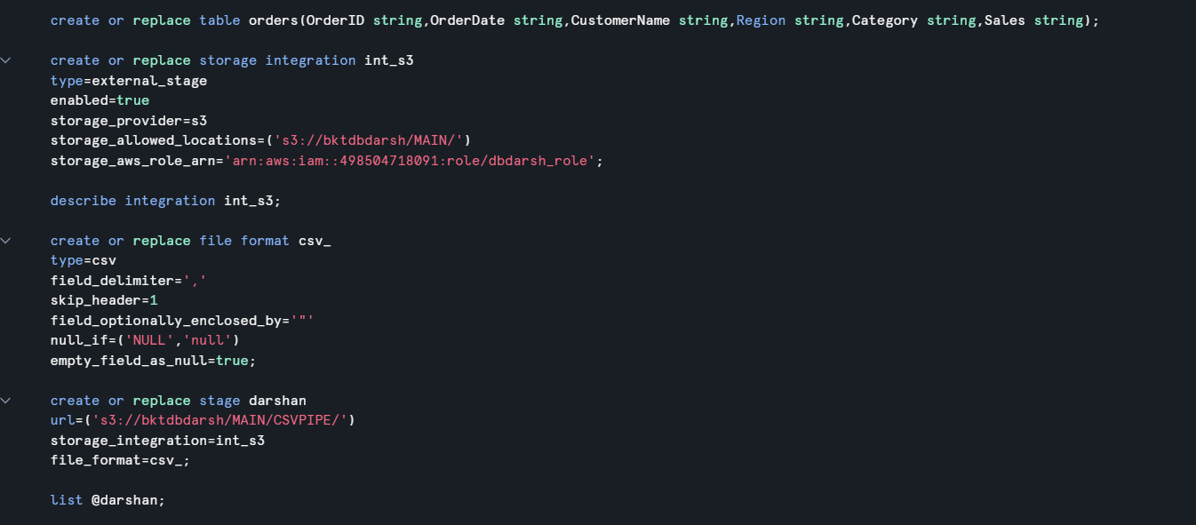
1b sql used for snowpipe creation
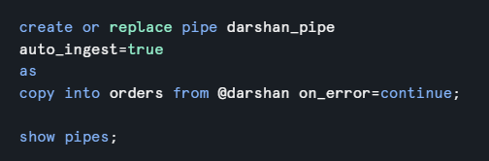
1c evidence of auto ingested data (query output showing inserted data)
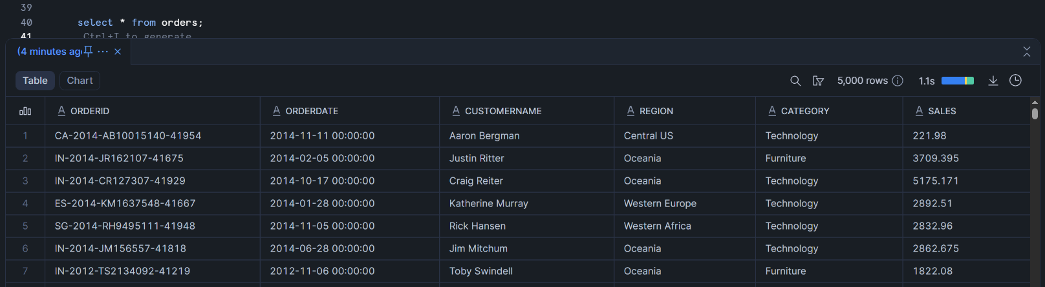

1d snowpipe load history
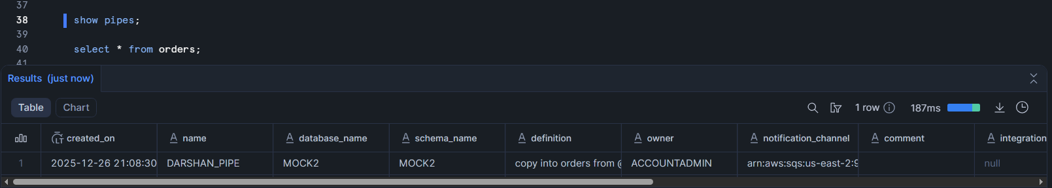

Q2 Snowflake zero copy cloning of database, schema and table
2a sql used for database cloning
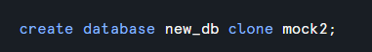
2b sql used for schema cloning
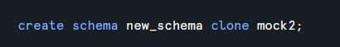
2c sql used for table cloning
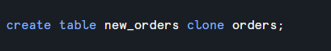
2d sql used for dml operation on the clone
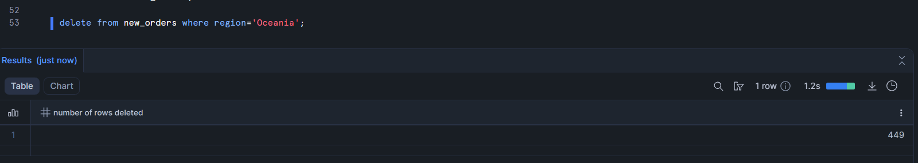
2e query output validating clone isolation
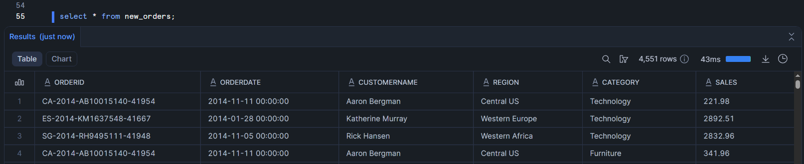
Q3 dynamic data masking and row access policy using roles
3a sql used for role creation and privilege grants
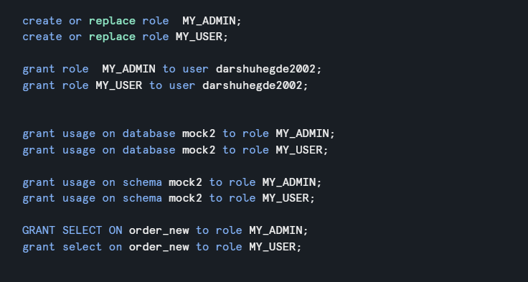

3b sql used for the masking policy creation
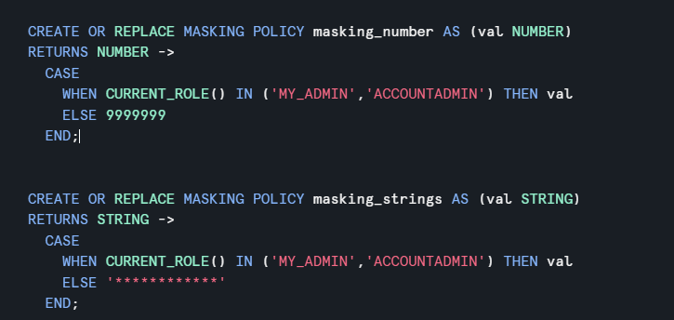

3c sql used to apply masking policies
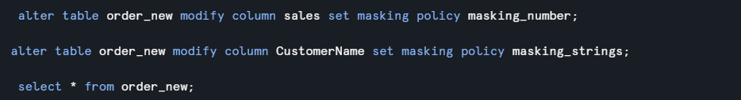

3d sql used for row access policy creation and assignment
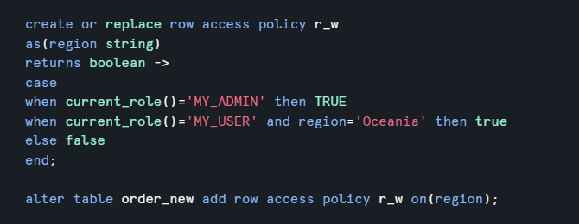

3e query output
Masked vs unmasked columns
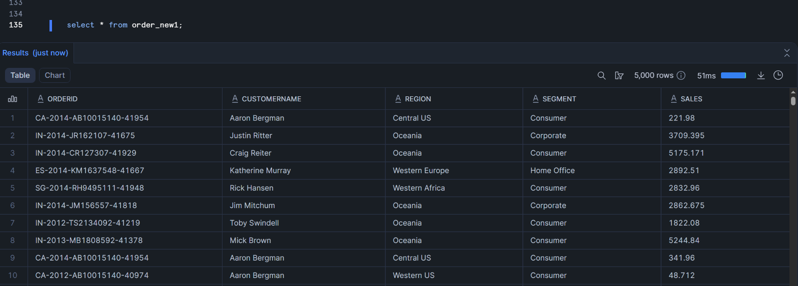

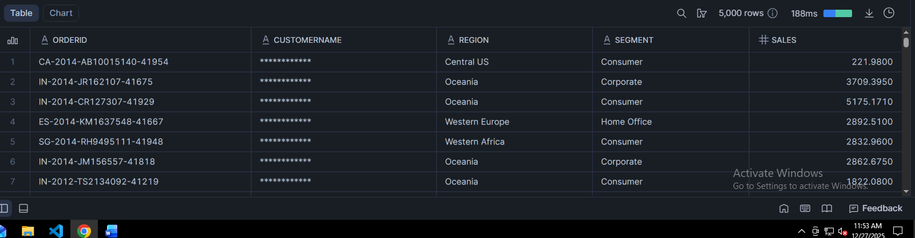
Row level access difference
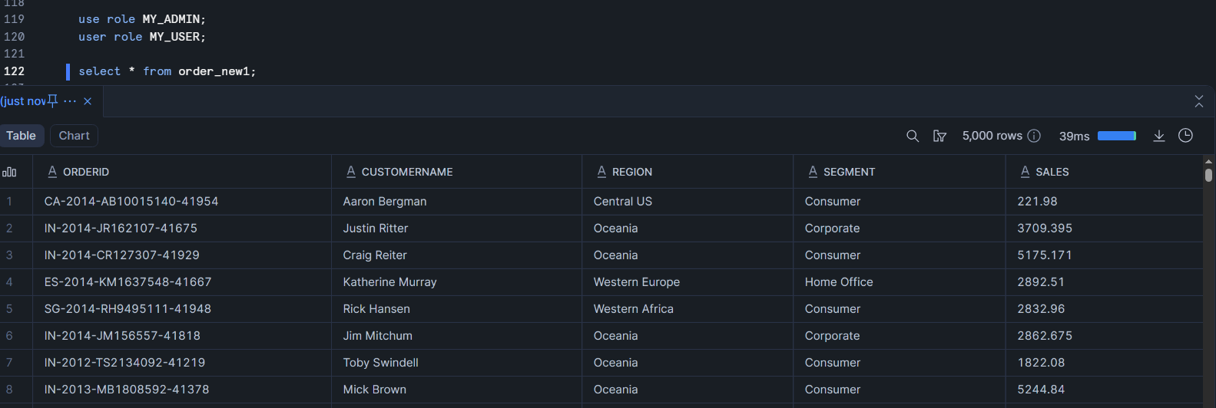
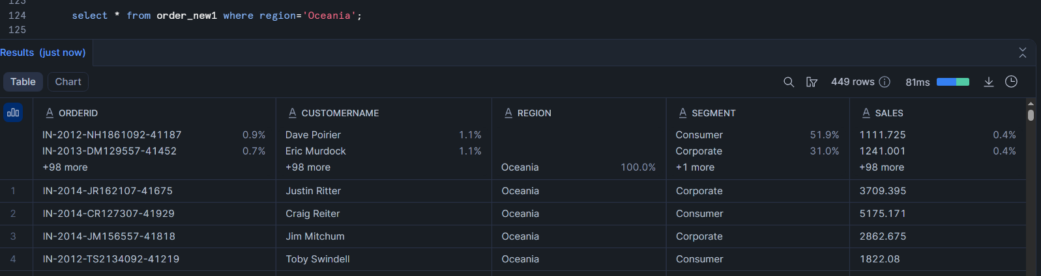

Q4 Snowflake AWS S3 External Stage data load and secure data sharing
4a SQL used for external stage creation and table creation
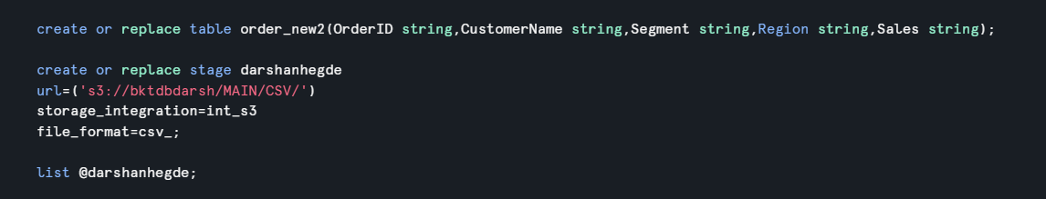

4b sql used for loading data from aws s3
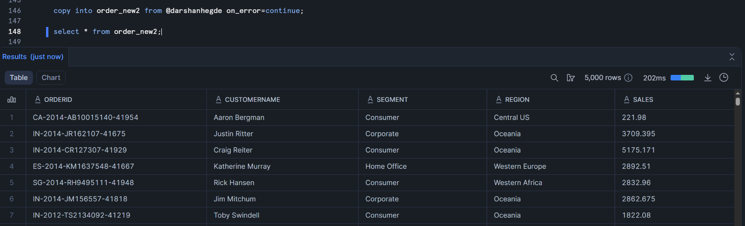

4c sql for secure view creation


4d sql used for data share configuration
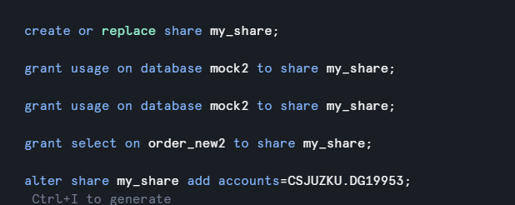

4e output validating that the data share is active
